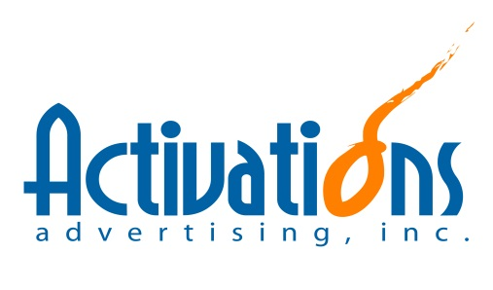
JOB ORDER NO.: ___________________ DATE: September 5, 2015
Ambient Tie-ups
Sampling Activations/Events
Others

CLIENT: Unilever Philippines – Marketing
PRODUCT: Dove Skin Cleansing
PROJECT: DCC Activation 2015 (2nd Wave)
ACCOUNT HANDLER: Kim Chua

ANIMATION DETAILS:
- Push selling for Dove Masterbrand promo packs
Particulars | Target Activity | Target Schedule | Target Hits |  |  | Target Duration | No. of Areas
 |  |  | Selling | Flyering | Survey
Rural Area Malls | Selling + Flyering + Survey | Sat-Sun | 120 | 3500 | 120 | 2 Days/Venye | 20
Gov't Offices | Selling + Flyering + Survey | Mon-Fri | 120 | 2500 | 120 | 2 Days/Venye | 15

REQUIREMENTS:
DEPARTMENT | DELIVERABLES |  | DEADLINE | NEXT STEPS
CREATIVES |  | N/A | N/A
OPERATIONS SUPPORT |  | 1. Negotiation, coordination with the venue  2. Oversee and monitor project status and updates  3. Other logistics and operationals | Open
ACTIVATIONS |  | 1. Oversee and monitor project status and updates  2. Facilitate budget and vehicle requests  3. Facilitate manpower briefing/simulation  4. Facilitate checking of all needed materials  5. Facilitate actual implementation | Open
PRODUCTION |  | N/A | N/A
SET-UP/LOGISTICS |  | Please see attached file | Open
PURCHASE/INVENTORY |  | Please see attached file | Open
HR |  | Please see attached file | Open
ACCOUNTING |  | N/A | N/A | N/A

ATTACHMENTS:
Working Cost Estimate
Working Deck
Working Checklist

RECEIVED:
_________________________________
Operations Division

